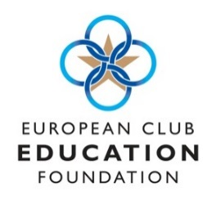
Application for ECEF Young Manager
Bursary 2024
Full Name:

Signed ………………………………………………………………………. Date …………………………..
Application Deadline: 27 April 2024
Personal Statement (in no more than 750 words explain why you feel you qualify for the bursary, and how by completing MDP 1 it will positively affect your career ambitions in the Club industry)
Address:
Club/Employer (if applicable):
Email Address:
Tel. Number:
Date of birth:

