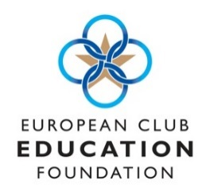
Application for ECEF Women in Golf
Bursary 2022(funded by The R&A)
Full Name:

Signed ………………………………………………………………………. Date …………………………..
Application Deadline: September 30th 2022
Personal Statement (in no more than 750 words explain: why you feel you qualify for the bursary; what you hope to achieve from a personal development perspective; and how, by completing MDP 1, it will positively impact your career ambitions in the Club industry.
Address:
Club/Employer (if applicable):
Email Address:
Tel. Number:
Date of birth:

