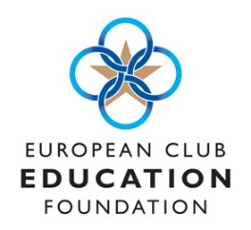


Application for CMAE European Conference Bursary 2021
Kerry London, part of the Kelliher Insurance Group is keen to support all prospective and current Club Managers to fulfil their potential in an often demanding profession. Imogen Coggan ,CEO, wants to provide one fortunate person the opportunity to attend virtually the three day 2021 European Conference on Club Management. Kerry London will pay the delegate fee (£295) for any first-time attendee to Conference who can show in 750 words their commitment to using the knowledge gained to improve their Club.

Eligibility to apply:

- You must be a CMAE member
- You must be currently employed in club management (eg Supervisor or Manager)
- You haven’t attended the World or European Conferences on Club Management before.

Full Name:
Date of birth:
Tel. Number:
Email Address:
Club:
Address:
Personal Statement (in no more than 750 words explain how by attending the European Conference on Club Management it will positively affect the work you do at your Club)

Signed ………………………………………………………………………. Date …………………………..

To opt in to receive information from Kerry London tick here
Applications to be sent to debbie.goddard@cmaeurope.org by 22nd October 2021

