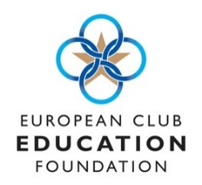
Application for ECEF Young Manager
Bursary 2019
Full Name:
Date of birth:
Tel. Number:
Email Address:
Club/Employer (if applicable):
Address:
Personal Statement (in no more than 750 words explain why you feel you qualify for the bursary, and how by completing MDP 1 it will positively affect your career ambitions in the Club industry)

Signed ………………………………………………………………………. Date …………………………..

